# Exercise 3 - Using SAS from JMP

JMP can integrate with SAS quite easily, allowing:

* Connecting to SAS
* Defining how the connection behaves in various ways
* Moving data to between JMP and SAS

1. File - SAS

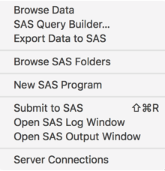

1. Server Connections

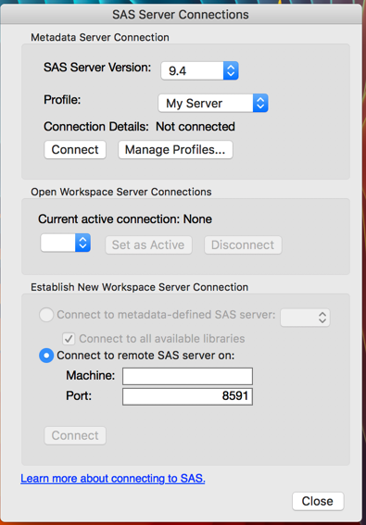

1. Click on Manage Profiles

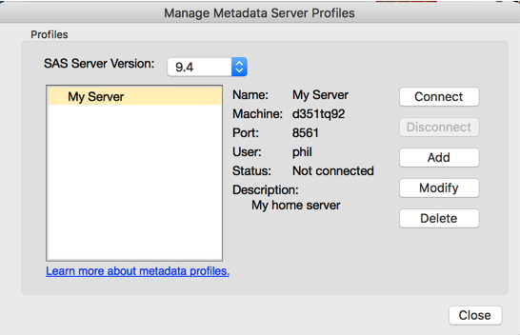

1. Click on Add

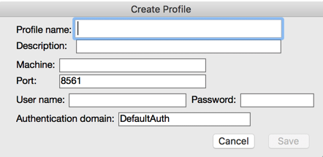

1. Enter the following details:
   1. Profile name: can be anything you like
   2. Descripton: not required
   3. Machine:
   4. Port:
   5. User name:
   6. Password:
   7. Authentication domain: DefaultAuth
   8. finally, click on Save
   9. Select your profile and press Connect button
   10. when connected, press Close button
2. Connect to a new workspace server connection

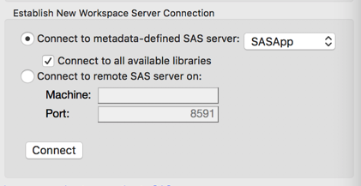

1. You should now see you are connected

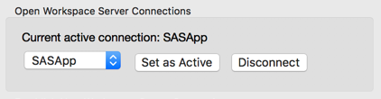

* 1. press Close button

1. JMP/Preferences/SAS Integration  
   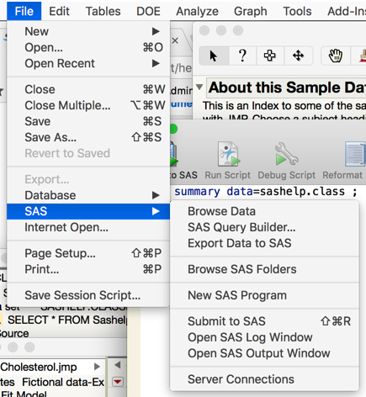  
   

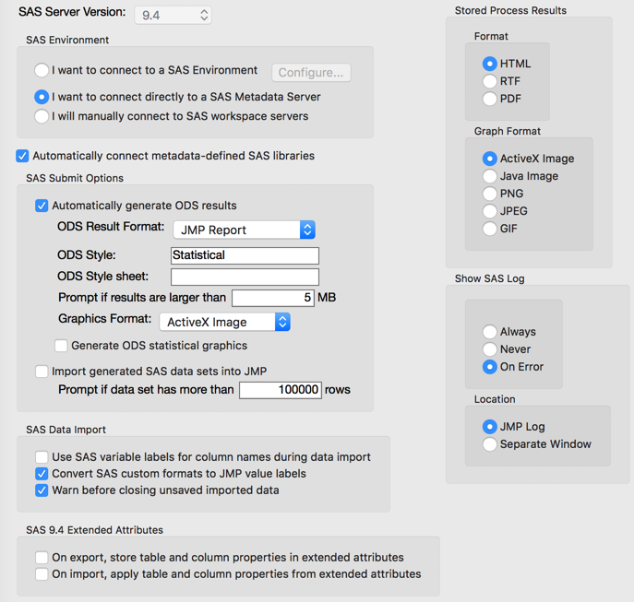

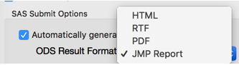

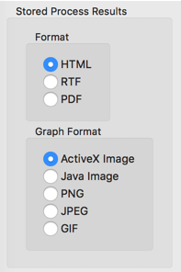

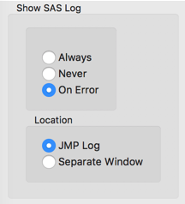





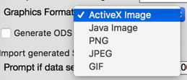





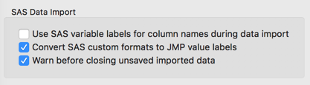

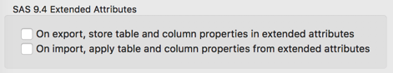

1. File/SAS/Browse Data
2. explore the data available
   1. clicking on Libraries to see tables in a library
   2. click on a table to see columns in that table, and a data Preview at the bottom
   3. click on a column to see its attributes
   4. select sashelp.classfit
   5. click on import button
3. you now have a SAS table in JMP
   1. Top left shows the SQL used to import your table
4. Go back to Browse SAS data and try importing some other tables
5. use some of the import options

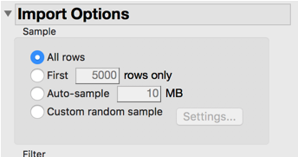

* 1. Try using the filter, to enter a where clause

1. try entering some Custom SQL

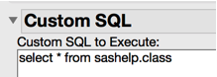

* 1. Remember to use the grey arrows to fold away panels of info 

1. Export data to SAS
   1. open some data using Help/Sample Data, then finding a table
2. File/Export
   1. Text, will let you save a CSV file or other
   2. JSON, used in many Internet technologies
   3. EXCEL
   4. SAS, makes into a sas7bdat file
   5. SAS Transport
3. File/SAS/Export data to SAS
   1. select data to export - pick the open table to export
   2. select destination Server and Library
4. Export options
   1. save JMP metadata, means we can load it back to JMP and restore metadata